 Northwestern Polytechnic University

CE450L Fundamentals of Embedded Engineering Lab
2021 Spring Midterm Exam

Student Name: Jenish Patel ID: 19549

- What are embedded system basic requirements? What is ARM processor architecture?
Ans:
Requirements for Embedded Systems:
- Performance
- Efficiency
- Reliability
- Robustness
- Safety
- Security
- Usability
The ARM cortex microcontroller is an advanced microcontroller in the ARM family, which is developed by the ARMv7 architecture. The ARM cortex family divided into three sub-families such as;
- ARM-Cortex Ax-series:

- ARM-Cortex Rx-series:

- ARM-Cortex Mx-series

The cortex-M3 ARM processor is a high performance 32-bit processor, which offers the significant benefits to the developers. The ARM architecture is a ‘Harward architecture’ which offers separate data and instruction buses for communicating with the ROM and RAM memories. It consist a 3-stage pipeline to fetch, decode and execute the instructions sequentially. The Cortex processor is a cost sensitive device which is used to reduce the processor area and has extensive improving interrupt handling and system debug capabilities.
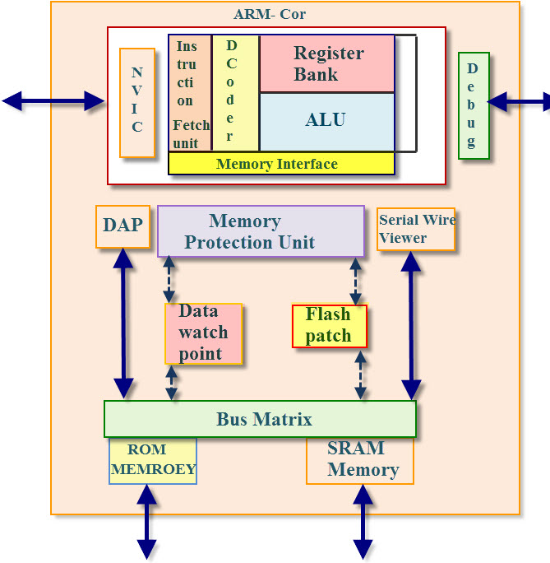
The cortex-M3 arm processors are implemented by THUMB instruction set based on THUMB-2 technology, therefore, ensures high code density and reduce the program memory requirement. The cortex-m3 instruction set provides the excellent performance due to modern 32-bit architecture. The ARM processor core-m3 is closely integrated to Nested Vector Interrupt Controller (NVIC) to provide the good interrupt performance.
Additional Features of the Cortex-M3 Processor
It is a RISC Controller
- 32-bit high performance CPU
- 3-stage pipeline and compact one
It has THUMB-2 technology
- Optimal merges of 16/32 bit instructions
- High performance
It supports tools and RTOS and It has core Sight debug and trace
- JTAG or 2-pin serial wire debug connection
- Support for multiple processors
Low power Modes
- It supports sleep modes
- Control the software
- Multiple power domains
Nested vectored interrupt controller (NVIC)
- Low latency, low jitter interrupts response
- No need for assembly programming

- Describe hardware components for a mini embedded system with OS.
Ans:

Embedded System Hardware:
As with any electronic system, an embedded system requires a hardware platform on which it performs the operation. Embedded system hardware is built with a microprocessor or microcontroller. The embedded system hardware has elements like input output (I/O) interfaces, user interface, memory and the display. Usually, an embedded system consists of:
- Power Supply
- Processor
- Memory
- Timers
- Serial communication ports
- Output/Output circuits
- System application specific circuits
- The processor (CPU) -- A processor can be thought of as the brain of the device. It processes and responds to various instructions that direct the microcontroller's function. This involves performing basic arithmetic, logic and I/O operations. It also performs data transfer operations, which communicate commands to other components in the larger embedded system.
- Memory -- A microcontroller's memory is used to store the data that the processor receives and uses to respond to instructions that it's been programmed to carry out. A microcontroller has two main memory types:
  - Program memory, which stores long-term information about the instructions that the CPU carries out. Program memory is non-volatile memory, meaning it holds information over time without needing a power source.
  - Data memory, which is required for temporary data storage while the instructions are being executed. Data memory is volatile, meaning the data it holds is temporary and is only maintained if the device is connected to a power source.
- I/O peripherals -- The input and output devices are the interface for the processor to the outside world. The input ports receive information and send it to the processor in the form of binary data. The processor receives that data and sends the necessary instructions to output devices that execute tasks external to the microcontroller.
While the processor, memory and I/O peripherals are the defining elements of the microprocessor, there are other elements that are frequently included. The term I/O peripherals itself simply refers to supporting components that interface with the memory and processor. There are many supporting components that can be classified as peripherals. Having some manifestation of an I/O peripheral is elemental to a microprocessor, because they are the mechanism through which the processor is applied.
Other supporting elements of a microcontroller include:
- Analog to Digital Converter (ADC) -- An ADC is a circuit that converts analog signals to digital signals. It allows the processor at the center of the microcontroller to interface with external analog devices, such as sensors.
- Digital to Analog Converter (DAC) -- A DAC performs the inverse function of an ADC and allows the processor at the center of the microcontroller to communicate its outgoing signals to external analog components.
- System bus -- The system bus is the connective wire that links all components of the microcontroller together.
- Serial port -- The serial port is one example of an I/O port that allows the microcontroller to connect to external components. It has a similar function to a USB or a parallel port but differs in the way it exchanges bits.

We need a program written in assembly or in embedded c language. And then we compile it. This compiled code converted into HEX code. This hex code is programmed or burned into the ROM of the system using some programmer.
A system is said to be real time, if it is essential to complete its work and deliver its service on time. Real time operating system manages the application software and affords a mechanism to let the processor run. The Real Time operating system is responsible for handling the hardware resources of a computer and host applications which run on the computer.
An RTOS is specially designed to run applications with very precise timing and a high amount of reliability. Especially, this can be important in measurement and industrial automation systems wherein downtime is costly or a program delay could cause a safety hazard.

- Give some examples about I/O components in an embedded system.
Ans:
Embedded system is defined as a way of working, performing or organizing one or many tasks according to a fixed set of rules (or) an arrangement in which all the units assemble and work together according to the program or plan. Examples of embedded systems are a watch and a washing machine.
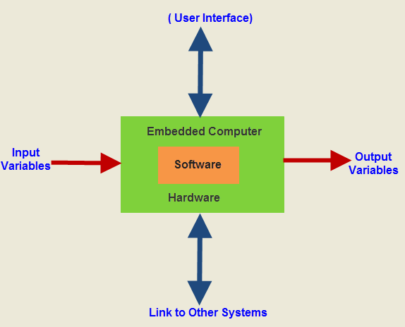
An embedded system is a system that has software embedded in computer hardware. It makes a system dedicated to a specific part of an application or product of a larger system. Depending on the application, the embedded system may be programmable or non-programmable.
Examples of embedded systems include various products such as washing machines, microwave ovens, cameras, printers and automobiles. They use microprocessors and microcontrollers as well as specially designed processors such as digital signal processors (DSP).
All embedded systems include some form of input and output (I/O) operations
Examples of embedded systems built explicitly to deal with I/O devices: Cell phone, pager, and a handheld MP3 player
I/O operations are interpreted differently depending on the viewpoint taken and place different requirements on the level of understanding of the hardware details
Interfaces between a device and the main processor occur in two ways: port mapped and memory mapped
DMA controllers allows data transfer bypassing the main processor
I/O subsystems must be flexible enough to handle a wide range of I/O devices.
Uniform I/O hides device peculiarities from applications.
The I/O subsystem maintains a driver table that associates uniform I/O calls with driverspecific I/O routines.
The I/O subsystem maintains a device table and forms an association between this table and the driver table

- Compare the different functions of NOR flash and NAND flash in embedded system.
Ans:
The two main types of flash memory are the NOR Flash & NAND Flash. Intel is the first company to introduce commercial (NOR type) flash chip in 1988 and Toshiba released world's first NAND-flash in 1989.
NOR-flash is slower in erase-operation and write-operation compared to NAND-flash. That means the NAND-flash has faster erase and write times. More over NAND has smaller erase units. So fewer erases are needed. NOR-flash can read data slightly faster than NAND.
NOR offers complete address and data buses to randomly access any of its memory location (addressable to every byte). This makes it a suitable replacement for older ROM BIOS/firmware chips, which rarely needs to be updated. Its endurance is 10,000 to 1,000,000 erase cycles. NOR is highly suitable for storing code in embedded systems. Most of the today's microcontrollers comes with built in flash memory.
NAND-flash occupies smaller chip area per cell. This maker NAND available in greater storage densities and at lower costs per bit than NOR-flash. It also has up to ten times the endurance of NOR-flash. NAND is more fit as storage media for large files including video and audio. The USB thumb drives, SD cards and MMC cards are of NAND type.
NAND-flash does not provide a random-access external address bus so the data must be read on a block-wise basis (also known as page access), where each block holds hundreds to thousands of bits, resembling to a kind of sequential data access. This is one of the main reasons why the NAND-flash is unsuitable to replace the ROM, because most of the microprocessors and microcontrollers require byte-level random access.
A write operation in any type of flash device can only be performed on an empty or erased unit. So in most cases write operation must be preceded by an erase operation. The erase operation is fairly straightforward in the case of NAND-flash devices. But for a NOR-flash, it is mandatory that all bytes in the target block should be written with zeros before they can be erased.
The size of an erase-block in NOR-flash ranges from 64 to 128 Kbytes. Here a write/erase operation can take up to 5 s. But the NAND-flash has erase blocks 8 to 32 Kbytes in size. So it is obvious that the NAND performs the identical operation in a lesser time duration.
INOR-flash interface resembles closely to a SRAM memory interface, which has enough address pins to map its entire media, allowing for easy access to every byte contained in it, where as the NAND-flash go for serially accessed complicated I/O mapped interface. Here the same pins are used for control, address & data.
In traditional single-level cell flash devices, each cell stores only one bit of information. Later, many developers have developed a new form of flash memory known as multi-level cell flash that can store/hold more than one bits rather than a single bit in each memory cell, thus doubling the capacity of memory.
PARAMETER | NOR | NAND
Capacity | 1 to 16 Mbytes | 8 to 128 Mbytes
XIP (code execution) | Yes | No
Performance Erase  Write  Read | Very Slow (5 s)  Slow  Fast | Fast (3 ms)  Fast  Fast
Strengths | Addressable to every byte | More than 10% higher life expectancy
Erase cycle range | 10,000 to 100,000 | 100,000 to1,000,000
Interface | SRAM-like, memory mapped | Accessed in bursts of 512 bytes; I/O mapped
Access method | Random | Sequential
Price | High | Very low

- Describe how DMA works by some examples
Ans: DMA or the direct memory access is nothing but a means of having the peripheral device control a processor's memory bus directly. DMA actually permits the peripherals to transfer the data directly to or from memory without having each byte handled by the processor. When the CPU is using the programmed I/O it occupies for the entire duration of the read/write operation and thus unable to perform the other functionalities. With the help of DMA, the CPU first initializes the transfer and then it performs other operations while the transfer is in the progress.and it finally receives interrupt signal from the DMA controller when the operation is executed properly. Sometimes, DMA is also being used for the memory to memory copying or even moving the data within the memory.
The DMA module make use of the system bus only when the processor does not require it, or it might force the processor to suspend the operation though temporarily. The latter technique is quite common and is referred as the cycle stealing.because the DMA module in function steals the bus cycle.

- Scrolling every OTHER LED blinking from the left to the right in eight of one line on the RPi board by LOOP program structure
Ans:
import RPi.GPIO as GPIO # include GPIO library in RPi
import time # include time system call in Raspbian

pins = [11, 12, 13, 15, 16, 18, 22, 7] # put all pinNO in a list data type, like array

def setup():
GPIO.setmode(GPIO.BOARD) # using board pin number
for pin in pins: # 1st iter. pin = 11, 2nd iter pin = 12,… …
GPIO.setup(pin, GPIO.OUT) # Set all pins' mode is output
GPIO.output(pin, GPIO.HIGH) # Set all pins to high(+3.3V) to switch off led
# pin11 = 1, pin12 = 1, … … pin7 = 1

def loop():
while True: # forever loop
for pin in pins(range(0,8,2)): # 1st iter. pin = 11, 2nd iter pin = 12,… …
GPIO.output(pin, GPIO.LOW)
print(pin) # # 1st iter.Pin11 = 0, switch on 1st led
time.sleep(0.05) # holding sw on 0.05Sec
GPIO.output(pin, GPIO.HIGH) # 1st iter.Pin11 = 1, switch off 1stled

for pin in reversed(pins(range(0,8,2))): # reversed() function
GPIO.output(pin+2, GPIO.LOW) # 1st iter.Pin7 = 0, switch on 1st led
time.sleep(0.05)
GPIO.output(pin+2, GPIO.HIGH)

def destroy():
for pin in pins:
GPIO.output(pin, GPIO.HIGH) # turn off all leds
GPIO.cleanup() # disable GPIO port

# --------- main function ---------------------
setup()
try:
loop()
except KeyboardInterrupt: # When 'Ctrl+C' is pressed, the child program destroy() will be executed.
destroy()

